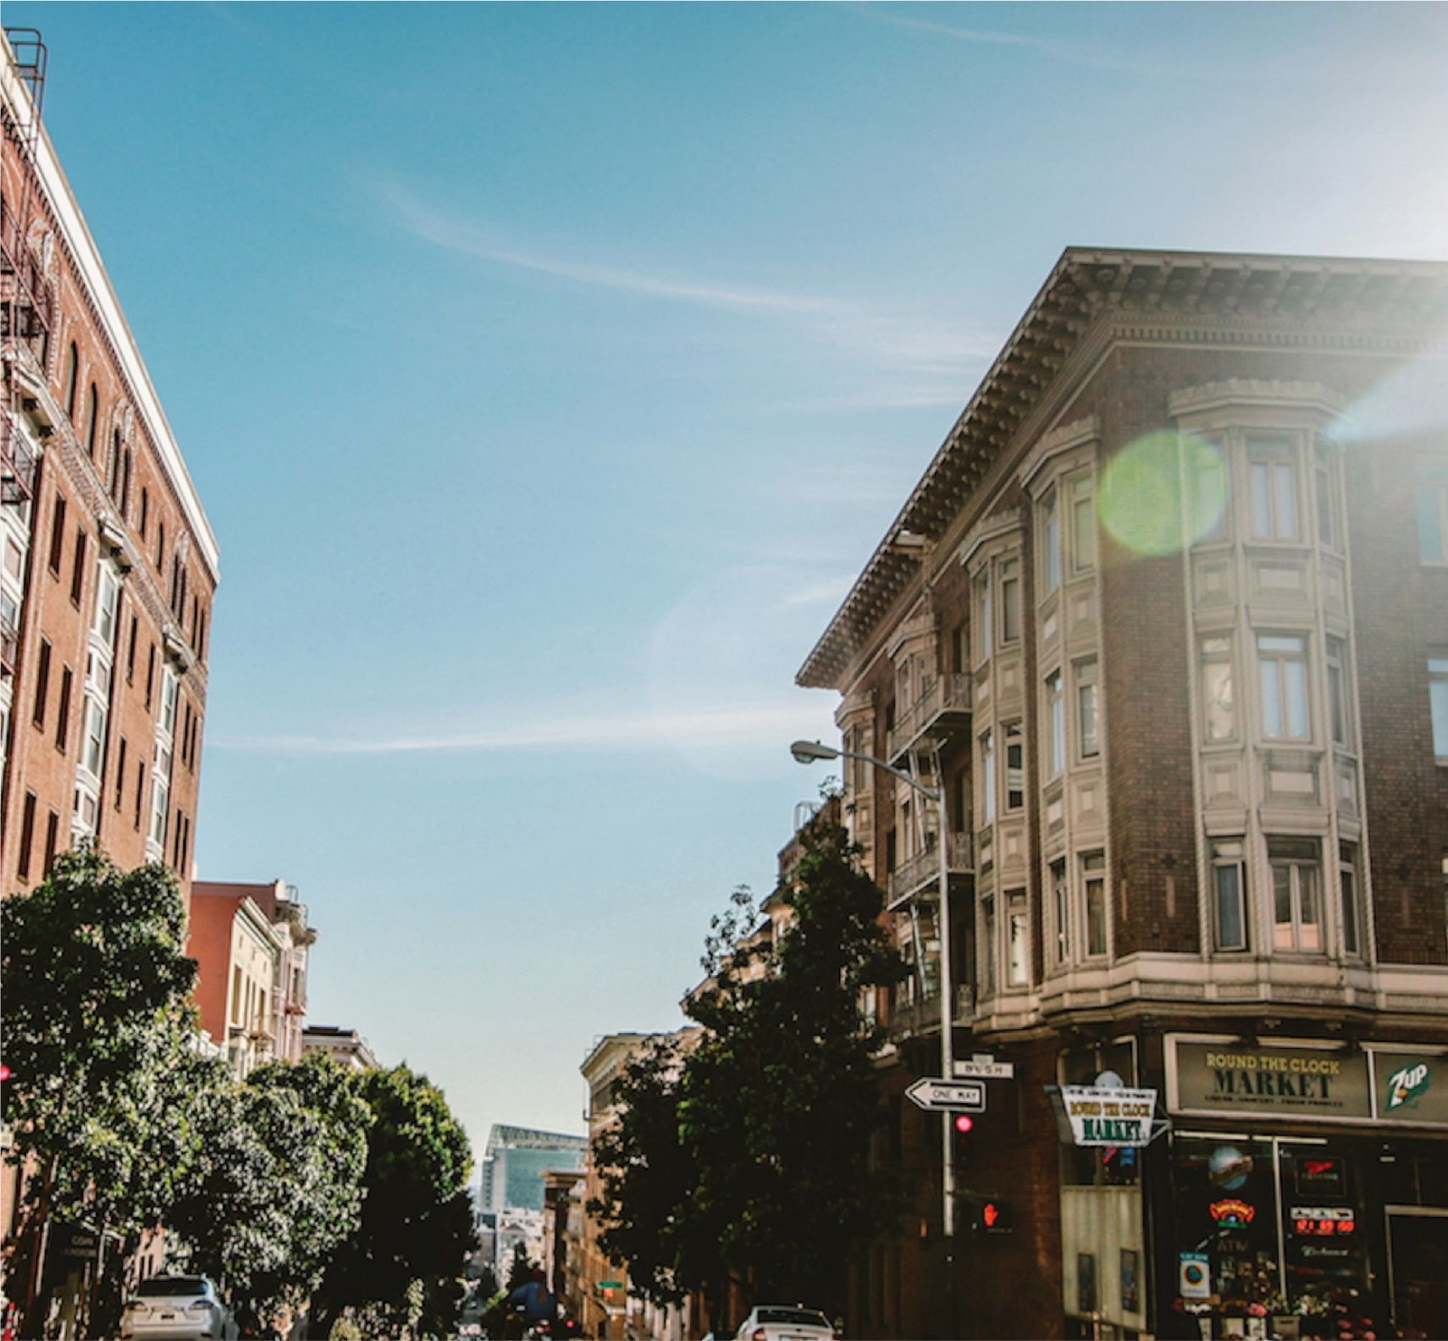
GUIDANCE DOCUMENT

FOOD HANDLING FOR BAKE SALES

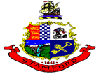
July 29, 2021

City of Stamford Department of Health
Safeguarding the Public’s Health
Norma Jarrett

PURPOSE - Guidance for Implementing Community - Bake Sales
The purpose of these guidelines is to minimize the risk of foodborne illness, and outbreaks at Community Bake Sales. By following these guidelines, you can help the City of Stamford ensure the safety of the foods served, and in turn, protect the health and safety of your patrons.

FOOD PROTECTION

One of the leading cause of foodborne illness & outbreaks is the failure to keep Time Temperature Control for Safety (TCS) Foods, at the proper temperature. Time Temperature Control for Safety Foods (TCS) are those consisting in whole, or part of milk, milk products, eggs, meat, poultry, fish, shellfish or other foods capable of supporting the rapid growth of infectious or toxigenic microorganisms. This includes hamburgers; pizza, cooked rice, beans, potatoes and other cooked vegetables; sliced melons, cream-filled pastries, as well as some of the more commonly accepted ethnic types of foods. These TCS foods are not recommended for bake sales.
When organizing bake sales use only foods that do not require temperature control for safety – these include most pastries, cookies and bread products.

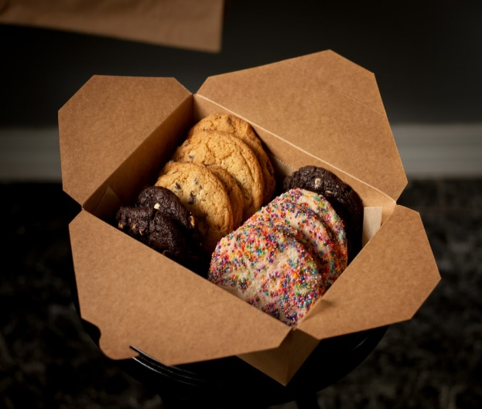
It is highly recommended that you purchase baked goods from a reputable commercial source for resale at bake sales - Supermarket, Restaurant Food Distributor, Licensed Bakeries etc.
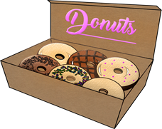

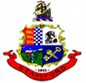

PRE PLANNING NOTES – BAKE SALE

- Ensure food products are, wrapped or sealed, before transporting to the bake sale.
- Vehicles used to transport food must be clean and maintained in good sanitary condition.
- Do not transport foods with family pets, cleaning solutions or medicines.
- Packages must be sealed, and not re - opened to sell part of the contents during the bake sale.
- The bake sale organizer shall maintain a list of contributors to the bake sale, including their name, telephone number and type of food donated. The food shall be labeled with the name of the person contributing the item. Products may be prepared by volunteers, in a commercial kitchen.
- Designate one individual to handle cash and others to handle food items.
- Make sure the foods for sale are fresh, wholesome and not expired.
- Procure enough stands/ tables to display all items off the floor.
- There should be no food preparation or packaging at the sales table.
- Wash rinse and sanitize food contact surfaces before use.
- Remind volunteers to call out if they are ill.
- Remind volunteers to wash hands when needed.
- Handling of unpackaged foods at the table requires handwashing facilities.

DISPLAY & SERVICE OF FOODS

- Do NOT offer Samples at the table
- Do not touch prepared foods and baked goods with your bare hands (use gloves, tissue, tongs or other method).
- Wash hands before and after glove use.
- There shall be no eating nor drinking while handling / serving foods.

“Store baked goods in clean, sanitized, dry, food-grade containers, and keep them covered, and off the floor.”
Do NOT handle ready to eat foods with bare - hands!

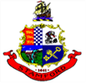

Label all packaged goods with the following:

- Common name of the product (e.g. chocolate chips cookies, apple pie).
- The product ingredients in descending order of predominance (that is, from most to least by weight). This is particularly important for customers with food allergies.
- Adequate declaration of the eight major food allergens – for example – “This Product was made in a kitchen that uses eggs, nut, tree nuts etc.”
- Have an identifying marker to track who made the product if homemade.

Foods that CANNOT be sold at a bake sale without a license include:-

- Home canned or processed meat, pickles and vegetables
- Homemade yogurt, cheese, or other dairy products
- Infused oils, dips and spreads
- TCS foods that require refrigeration – cheesecakes, cream puffs, flans and custards
- Foods that need refrigeration will need a special license from the Department of
Health
- Foods that require cooking or reheating will need a special license from the
Department of Health.
.

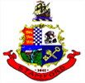

Foods that may be sold at a bake sale without a license include:-

- Commercially purchased cakes, breads, fruit pies, croissants, donuts, brownies, cookies.
- Homemade cookies, brownies, cakes, cupcakes (use dry baking mixes)
- Candies, Toffees,
- Homemade fruit pies (no cream fillings).
- Dried fruits and or nuts
- Granola Bars and Trail Mixes

Food safety IS our highest priority; if unsure of any procedures / actions, please contact the City of Stamford Department of Health @ stamfordct.gov/department-of-health

